User manual

# Project Introduction

The purpose of this project is to build and develop a web application hosted on a decentralised network to facilitate the transaction of electricity between users. The users can be not only the electricity consumer but also the producer with rooftop solar equipment. Unlike traditional supply systems which can only provide electricity to users, this system allows users to buy or sell excessive electricity among users. This project's scope is to build private online ledgers to process electricity transactions between users using blockchain technology. Due to the distributed feature of the blockchain, the electricity supply system is also distributed which is quite different from the existing system.

Built with:

* Hyperledger
* VUE + Springboot (Java)

# Get started

This is an example of how you may give instructions on setting up your project locally. To get a local copy up and running follow these simple example steps.

## Prerequisites

### Backend

This is an example of how to list things you need to use the software and how to install them.

* + docker
  + maven
  + Ssh

### Frontend

* Java 11
* node.js v15.14.0
* npm 7.7.6

1. curl -sL https://deb.nodesource.com/setup_15.x | sudo -E bash –
2. sudo apt-get install -y nodejs
3. node -v && npm -v

* Vue-cli

npm install -g @vue/cli

* Maven

sudo apt-get install Maven

## Installation

Clone the project into local directory:

git clone https:*//github.com/COMP5703-CS34/minifab-elec.git*

### Chaincode

1. Go to minifab-elec, pull the chaincode of this project into local directory
2. Move minifab-elec into DETS, and rename it as chaincode:
3. rm -rf DETS/chaincode
4. cp -r minifab-elec DETS/chaincode
5. Go to chaincode dir, initialize the chain:

sudo ./minifab up -o stateA.elec.com -i 2.1 -n elec-chaincode -l java -v 1.0 -d true -e true -p '"init"'

1. It may take 15-20 minutes to start the chaincode.

### Backend

1. When chaincode is set, you can get the host IP:

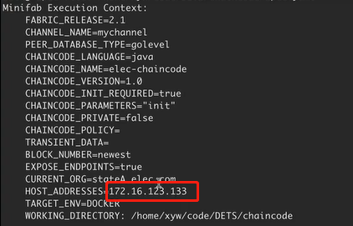

1. It should be same as the URL in :

*backend/src/main/java/com/backend/chain/hyperledger/HyperledgerEnrollAdmin.java*

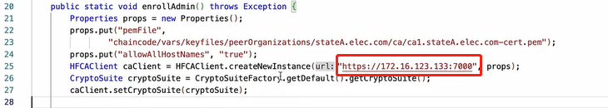

1. Check the resource file: there should be the ***application.properties*** file in *backend/src/main/resources* folder.

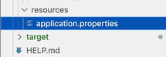

1. Copy the network configuration into the resources file:

cp chaincode/vars/profiles/mychannel_connection_for_gosdk.yaml backend/src/main/resources/connection.yaml

1. Go to backend dir:

cd backend

./mvnw spring-boot:run

Or just run the DemoApplication file

1. If successful you will see:

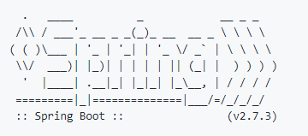

1. And in the few lines from the bottom:

INFO xxxx --- [  restartedMain] o.s.b.w.embedded.tomcat.TomcatWebServer  : Tomcat started on port(s): 3000 (http) with context path ''

And “admin” can successfully enroll into the chaincode:



1. Open a explore and enter:

https:*//localhost:3000*

### Frontend

1. Come to frontend directory:

cd vue

1. First time install or after big change:

npm install

1. Run frontend.

npm run serve

1. If successful, open random explorer and enter address shown on terminal, you will see the homepage. End frontend with ***Crtl + Z***

# **Make Transaction**

Administrator has been granted to add new users. Your account name and password will be told by administrator. Then you can input your account name and password to login.

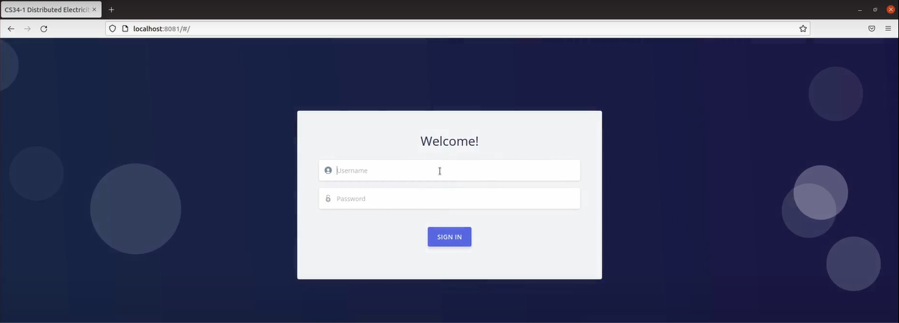

Once you have logged into the system, you will see the page like:

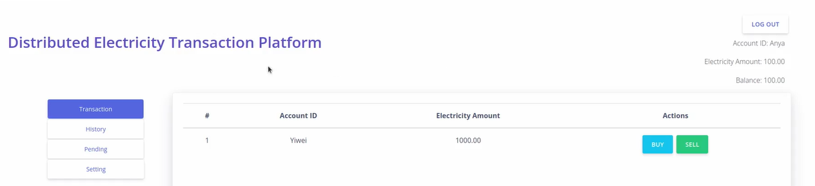

All your information, including your account name, electricity amount and balance is noticed:

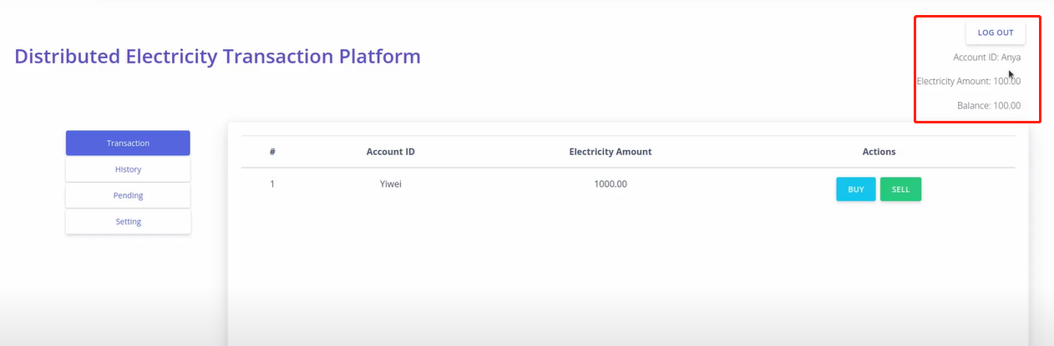

Here are the 4 tabs for core functions you can perform:

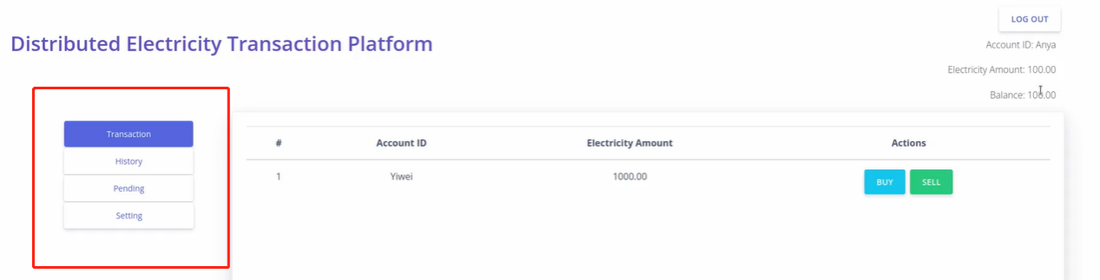

If it is the first time you log in to the system, you need to change your password at setting page. Then you can continue your transaction.

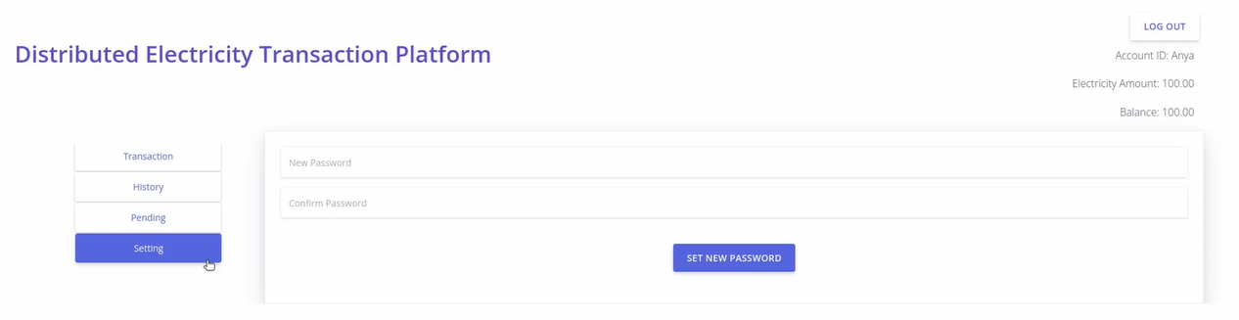

In transaction page, all tradable objects will be listed here, and you can apply for the “sell” or “buy” the subject's electricity

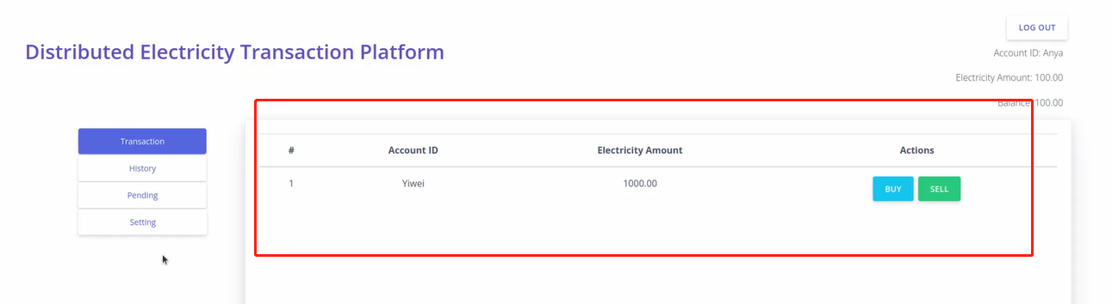

When you click on the "Buy" or "Sell" button, you have to fill in a form with the quantity of electricity and the price you want to buy or sell:

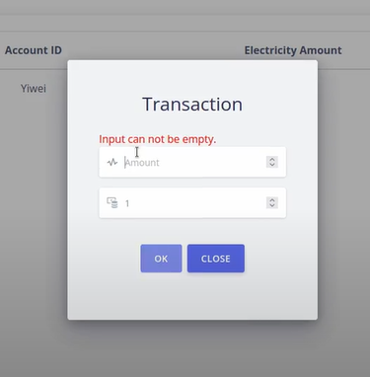

After click “OK” and “confirm”, you can see the a new request in your pending page. You can cancel it by click “cancel” button.

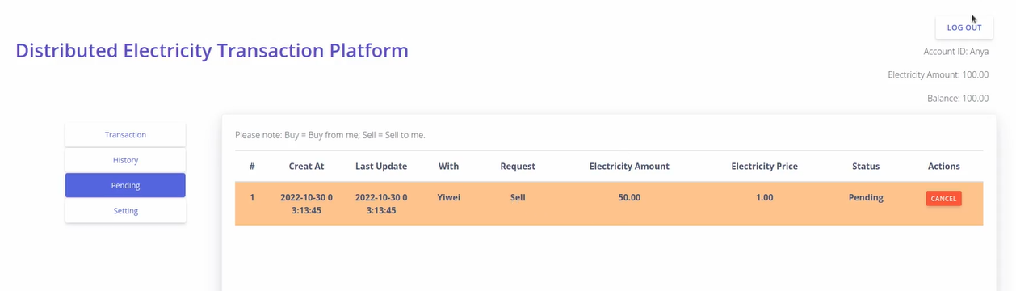

A request will also be sent to the person you are trading with and this request will be displayed on his/her pending page. The requested person can bargain, agree, or refuse to deal.

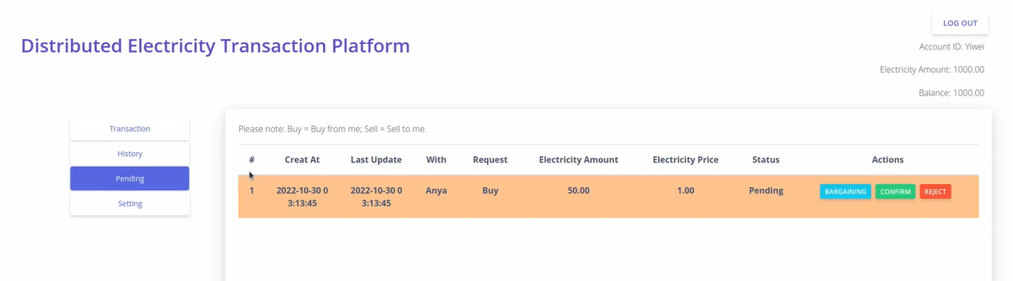

If the transaction is confirmed, the status will turn to accepted. The balance and electricity amount will also change.

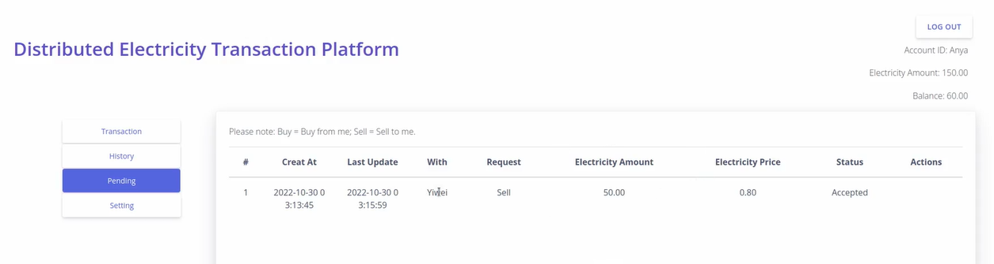

You can find your transaction history at history page:

